IBM CLOUD SERVICES

|  |  |
| --- | --- |
| BATCH | B3-3M5E |
| TEAM ID | PNT2022TMID17666 |
| TEAM MEMBERS | PRIYA-611619205039  VASUNTHARA-611619205055  JANANI -611619205015  JANANI ISHWARYA-611619205016 |
| PROJECT | IOT Based Safety Gadget for Child Safety Monitoring and Notification |

IBM CLOUD SERVICES

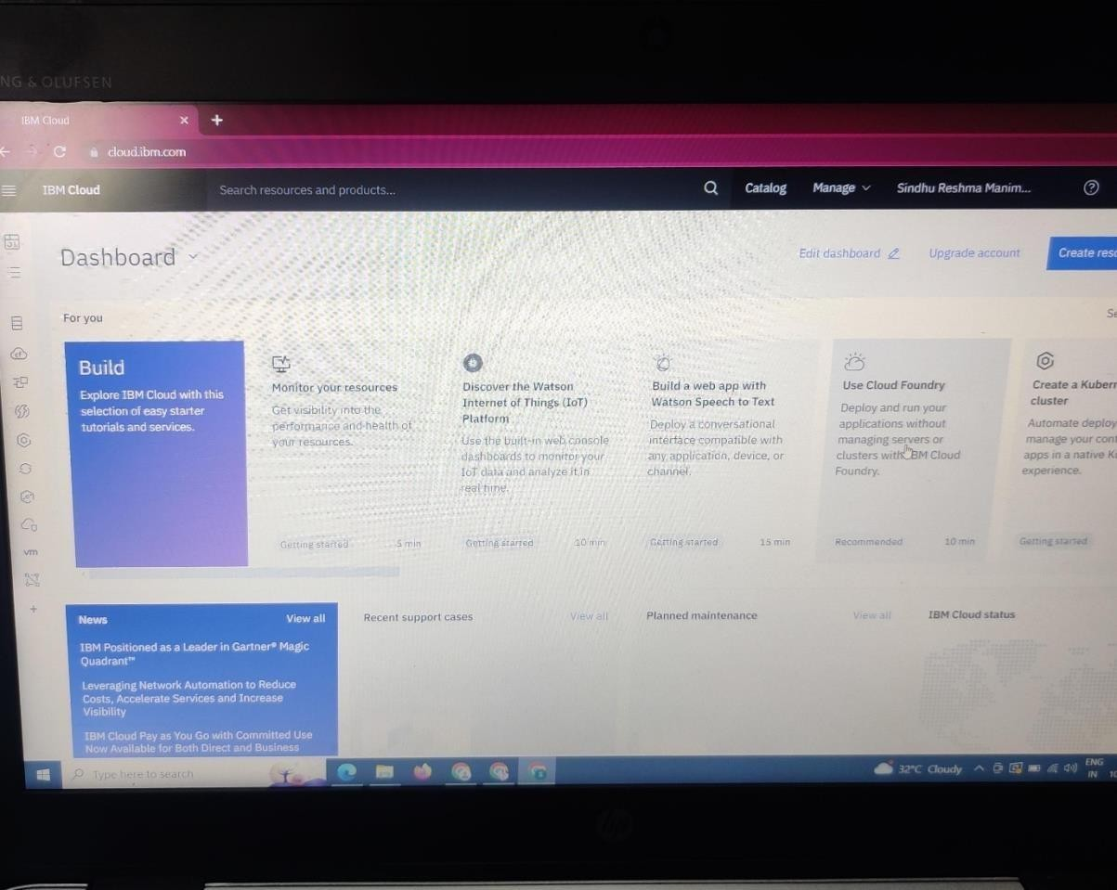

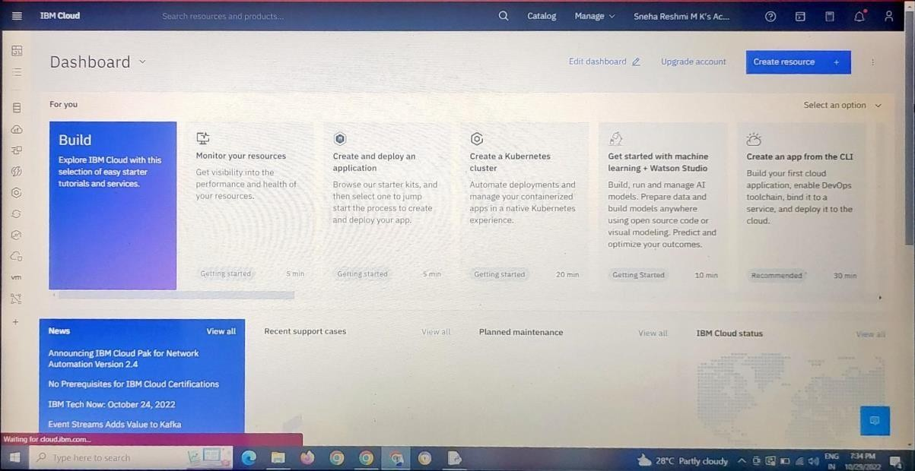

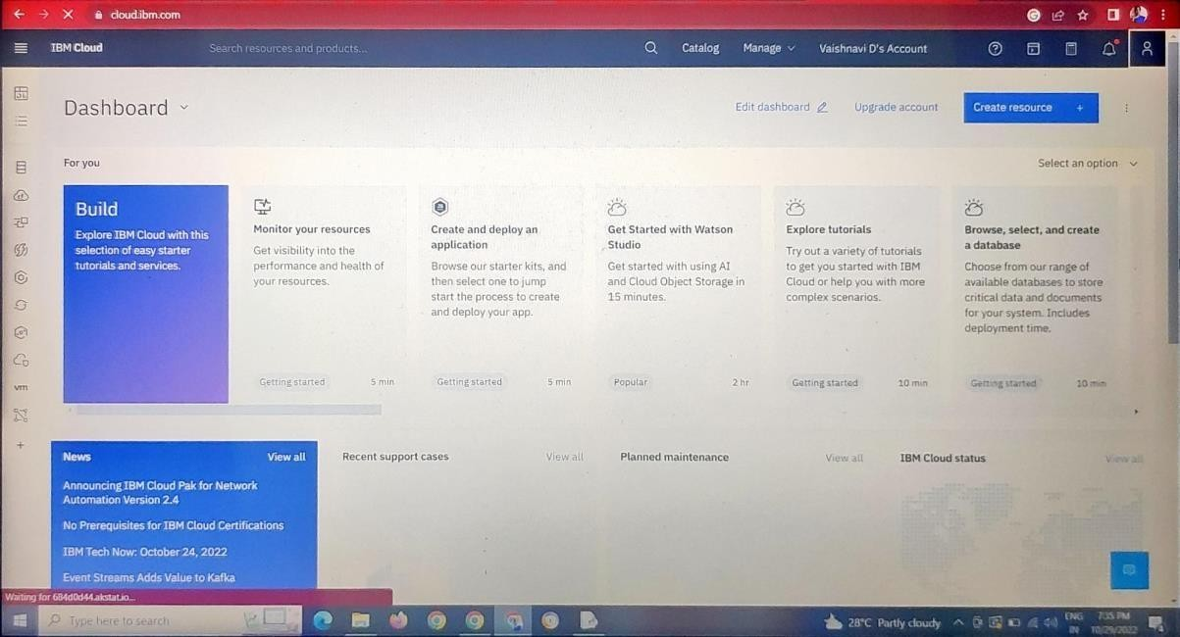

I

